

VL-PRO-PLUS Rev A0.1

Jumper and Connector Settings

User Manual

Released 2022/08/16
Features
- Intel® Tigger lake Processor
- DDR4 up to 3200 MHz SODIMM x 2, up to 64G
- LVDS1/LVDS2/eDP
- Audio Codec/AMP 5W X2
- Support 8-bit Digital I/O , 2 USB 2.0 , 4 USB 3.2
- M.2 E key 2230,M.2 M key 2280
- DC 12V only, AT/ATX Mode
- Realtek RTL8111H GbE LAN X2
Location of Connectors and Jumpers
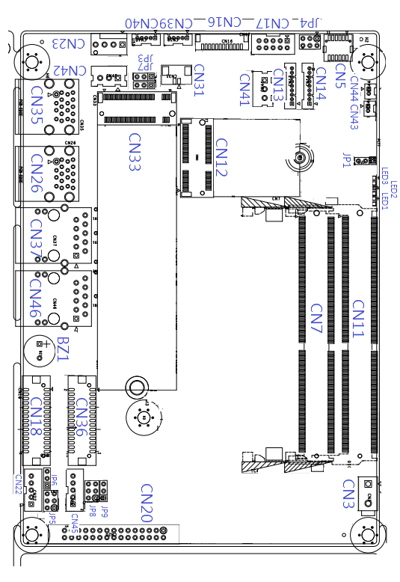

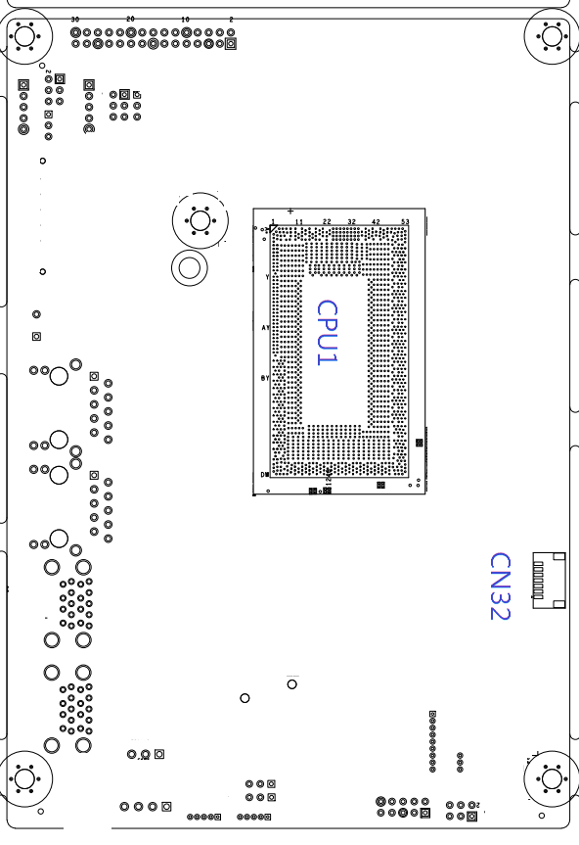
List of Jumpers
Jumpers allow users to manually customize system configurations to their suitable application needs.

The following chart consist the list of each jumper function:

Label | Function
JP1 | Front Panel Connector
JP3 | AT/ATX Selection
JP4 | COM2 Pin8 Function Selection
JP5 | LVDS1 Port Backlight Inverter VCC Selection  and Operating VDD Selection
JP6 | LVDS1 Port Backlight Lightness Control Mode Selection
JP7 | Clear CMOS Jumper
JP8 | LVDS2 Port Backlight Inverter VCC Selection  and Operating VDD Selection
JP9 | LVDS2 Port Backlight Lightness Control Mode Selection

(JP1) Front Panel Connector

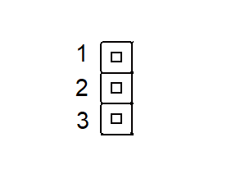
Pin 1 | EXT_PWR_BTN#
Pin 2 | GND
Pin 3 | H/W RESET#

(JP3) Auto Power Button Enable/Disable Selectio

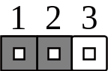  Disable/ATX | 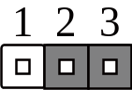  Enable/AT (Default)

(JP4) COM2 Pin8 Function Selection

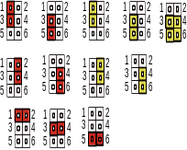 | Ring(Default) | +5V
  +12V | Ring(Default) | +5V
(JP5) LVDS1 Port Backlight Inverter VCC Selection

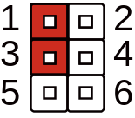  +12V | 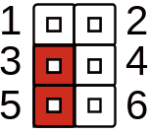  +5V (Default)

(JP5) LVDS1 Port VDD Selection

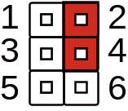  +3.3V (Default) | 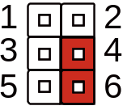  +5V | +5
  +5V

(JP6) LVDS1 Port Backlight Lightness Control Mode Selection

VR Mode | PWM Mode(Default)

(JP7) Clear CMOS Jumper
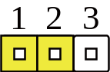  Normal (Default) | 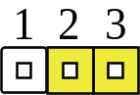  Clear CMOS

(JP8) LVDS2 Port Backlight Inverter VCC Selection

+12V | +5V (Default)

(JP8) LVDS2 Port VDD Selection

+3.3V (Default) | +5V | +5
  +5V
(JP9) LVDS2 Port Backlight Lightness Control Mode Selection

VR Mode | PWM Mode(Default)

List of Connectors
Connectors on board access link to external devices such as hard disk drives, a keyboard.
Label | Function
CN3 | External Power Input
CN5 | Audio I/O Port
CN7 | DDR4 SO-DIMM Slot
CN11 | DDR4 SO-DIMM Slot
CN12 | M.2 E Key 2230
CN13 | COM Port 1 RS232/422/485
CN14 | COM Port 2 RS232/422/485
CN16 | eSPI Debug Port
CN17 | Digital I/O Port
CN18 | LVDS1 Port CONN
CN20 | eDP CONN
CN22 | LVDS1 Port Inverter / Backlight Connector
CN23 | CPU FAN
CN26 | USB3.1 Port 1 / Port 2
CN31 | Battery CONN
CN32 | SPI BIOS Debug Port
CN33 | M.2 M Key 2280
CN35 | USB3.1 Port 3 / Port 4
CN36 | LVDS2 Port CONN
CN37 | LAN2 (RJ-45)
CN39 | USB 2.0 Port 5 CONN
CN40 | USB 2.0 Port 6 CONN
CN41 | GPIO sensor CONN1
CN42 | GPIO sensor CONN2
CN43 | AMP OUT_L CONN
CN44 | AMP OUT_R CONN
CN45 | LVDS2 Port Inverter / Backlight Connector
CN46 | LAN1 (RJ-45)

(CN3) External Power Input
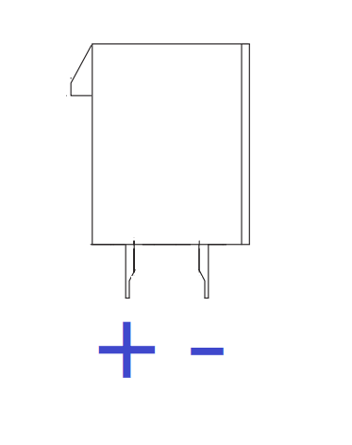
Pin | Pin Name | Signal Type | Signal level
1 | GND | GND
2 | +VIN | PWR | 12V(8A)

(CN5) Audio I/O Port
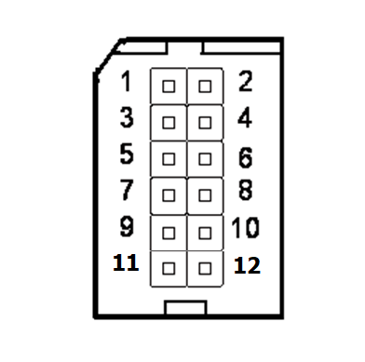

Pin | Pin Name | Signal Type | Pin | Pin Name | Signal Type
1 | LOUT_R | OUT | 2 | MIC_L | IN
3 | LOUT_L | OUT | 4 | MIC_R | IN
5 | JD_LOUT | IN | 6 | JD_MIC | IN
7 | AUD_GND | GND | 8 | AUD_GND | GND
9 | LINE_R_IN | IN | 10 | LIN_R | IN
11 | +VDD_AUD | PWR | 12 | LIN_L | IN
(CN7) DDR4 SO-DIMM Slot
Standard specification

(CN11) DDR4 SO-DIMM Slot
Standard specification

(CN12) M.2 E Key Slot 2230
Standard specification

(CN13) COM Port1

 | RS232
Pin | Pin Name | Signal Type | Signal level
1 | DCD | IN
2 | DSR | IN
3 | RX | IN
4 | RTS | OUT | ±5V
5 | TX | OUT | ±5V
6 | CTS | IN
7 | DTR | OUT | ±5V
8 | RI | IN
9 | GND | GND

 | RS485
Pin | Pin Name | Signal Type | Signal level
1 | RS485_ D- | I/O | ±5V
2 | NC
3 | RS485_D+ | I/O | ±5V
4 | NC
5 | NC
6 | NC
7 | NC
8 | NC
9 | GND | GND

(CN14) COM Port2
 | RS422
Pin | Pin Name | Signal Type | Signal level
1 | RS422_TX- | OUT | ±5V
2 | NC
3 | RS422_RX+ | OUT | ±5V
4 | NC
5 | RS422_RX+ | IN
6 | NC
7 | RS422_RX- | IN
8 | NC
9 | GND | GND

 | RS232
Pin | Pin Name | Signal Type | Signal level
1 | DCD | IN
2 | DSR | IN
3 | RX | IN
4 | RTS | OUT | ±5V
5 | TX | OUT | ±5V
6 | CTS | IN
7 | DTR | OUT | ±5V
8 | RI | IN
9 | GND | GND

 | RS485
Pin | Pin Name | Signal Type | Signal level
1 | RS485_ D- | I/O | ±5V
2 | NC
3 | RS485_D+ | I/O | ±5V
4 | NC
5 | NC
6 | NC
7 | NC
8 | +5V/+12V(0.5A) | PWR | +5V/+12V
9 | GND | GND

 | RS422
Pin | Pin Name | Signal Type | Signal level
1 | RS422_TX- | OUT | ±5V
2 | NC
3 | RS422_RX+ | OUT | ±5V
4 | NC
5 | RS422_RX+ | IN
6 | NC
7 | RS422_RX- | IN
8 | +5V/+12V(0.5A) | PWR | +5V/+12V
9 | GND | GND
※ COM2 RS-232/422/485 can be set by BIOS setting. Default is RS-232.
※ Pin 8 function can be set by JP4.

(CN16) eSPI debug Port

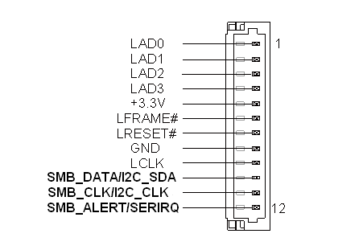

Pin | Pin Name | Signal Type | Signal level
1 | LAD0 | I/O | +3.3V
2 | LAD1 | I/O | +3.3V
3 | LAD2 | I/O | +3.3V
4 | LAD3 | I/O | +3.3V
5 | +3.3V | PWR | +3.3V
6 | LFRAME# | IN
7 | LRESET# | OUT | +3.3V
8 | GND | GND
9 | LCLK | OUT
10 | SMB_DATA/I2C_SDA | I/O
11 | SMB_CLK/I2C_CLK | OUT
12 | SMB_ALERT/SERIRQ | IN | +3.3V

(CN17) DIO CONN

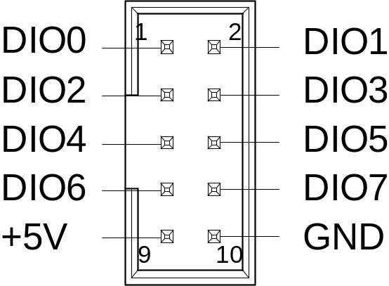

Pin | Signal Description | Pin | Signal Description
1 | PD0 | 2 | PD1
3 | PD2 | 4 | PD3
5 | PD4 | 6 | PD5
7 | PD6 | 8 | PD7
9 | +V5S(0.5A) | 10 | GND

(CN18) LVDS1 Port

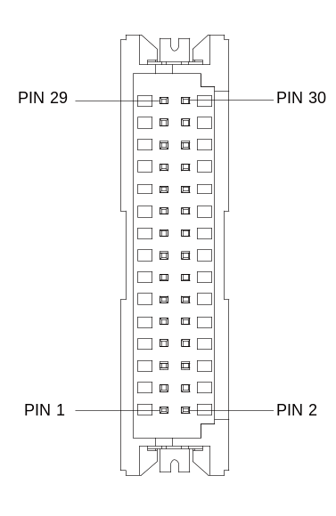
※ LVDS1 LCD_PWR current support => 2A
※ LVDS1 LCD_PWR can be set to +3.3V or +5V by JP5.
 | LVDS
Pin | Pin Name | Signal Type | Signal level
1 | BKL_ENABLE | OUT
2 | BKL_CONTROL | OUT
3 | LCD_PWR | PWR | +3.3V/+5V
4 | GND | GND
5 | LVDS_A_CLK- | DIFF
6 | LVDS_A_CLK+ | DIFF
7 | LCD_PWR | PWR | +3.3V/+5V
8 | GND | GND
9 | LVDS_DA0- | DIFF
10 | LVDS_DA0+ | DIFF
11 | LVDS_DA1- | DIFF
12 | LVDS_DA1+ | DIFF
13 | LVDS_DA2- | DIFF
14 | LVDS_DA2+ | DIFF
15 | LVDS_DA3- | DIFF
16 | LVDS_DA3+ | DIFF
17 | DDC_DATA | I/O | +3.3V
18 | DDC_CLK | I/O | +3.3V
19 | LVDS_DB0- | DIFF
20 | LVDS_DB0+ | DIFF
21 | LVDS_DB1- | DIFF
22 | LVDS_DB1+ | DIFF
23 | LVDS_DB2- | DIFF
24 | LVDS_DB2+ | DIFF
25 | LVDS_DB3- | DIFF
26 | LVDS_DB3+ | DIFF
27 | LCD_PWR | PWR | +3.3V/+5V
28 | GND | GND
29 | LVDS_B_CLK- | DIFF
30 | LVDS_B_CLK+ | DIFF

(CN20) eDP Port

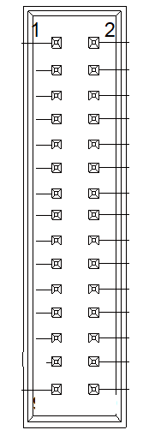
※ +VCC_EDP_BKLT current support => 1.2A
+VDD_eDP current support => 1.0A
 | eDP
Pin |  | Signal Type | Signal level
1 | +VDD_eDP | PWR | 3.3V
2 | +VDD_eDP | PWR | 3.3V
3 | GND | GND
4 | GND | GND
5 | DDIA_LANE0_DP_CON | DIFF
6 | DDIA_LANE0_DN_CON | DIFF
7 | GND | GND
8 | GND | GND
9 | DDIA_LANE1_DP_CON | DIFF
10 | DDIA_LANE1_DN_CON | DIFF
11 | GND | GND
12 | GND | GND
13 | DDIA_LANE2_DP_CON | DIFF
14 | DDIA_LANE2_DN_CON | DIFF
15 | GND | GND
16 | GND | GND
17 | DDIA_LANE3_DP_CON | DIFF
18 | DDIA_LANE3_DN_CON | DIFF
19 | GND | GND
20 | GND | GND
21 | DDIA_AUX_DP_CON | DIFF
22 | DDIA_AUX_DN_CON | DIFF
23 | GND | GND
24 | EDP_HPD_CON | I/O
25 | EDP_BKLTCTL_CON | I/O
26 | EDP_BKLT_EN_CON | I/O
27 | GND | GND
28 | GND | GND
29 | VCC_EDP_BKLT | PWR | 12V
30 | NC

(CN22) LVDS1 Port Inverter / Backlight Connector

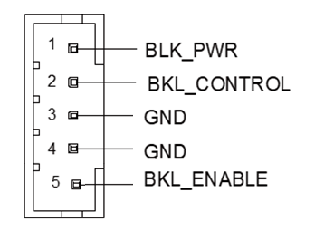
Pin | Pin Name | Signal Type | Signal level
1 | BKL_PWR | PWR | +5V / +12V
2 | BKL_CONTROL | OUT | +3.3V
3 | GND | GND
4 | GND | GND
5 | BKL_ENABLE | OUT | +3.3V

※ LVDS1 BKL_PWR can be set to +5V or +12V by JP5.
※ LVDS1 BKL_PWR current support => 1.5A
※ LVDS1 BKL_CONTROL can be set by JP6.

(CN23) CPU FAN

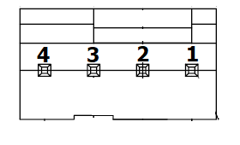
Pin | Pin Na me | Signal Type | Signal level
1 | GND | GND
2 | FAN_POWER | PWR | +12V (1A)
3 | FAN_TAC | IN
4 | FAN_CTL | OUT

(CN26) USB Ports 1 and 2

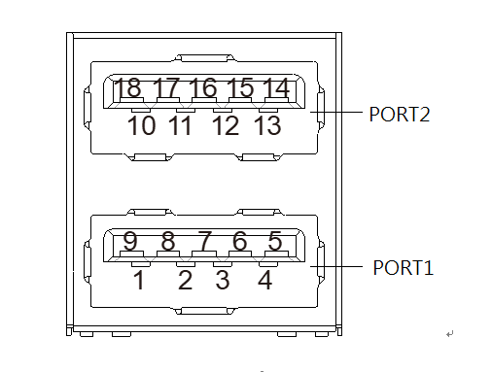

Pin | Pin Name | Signal Type | Signal level
1 | +5VSB | PWR | +5V(0.9A)
2 | USB1_D- | DIFF
3 | USB1_D+ | DIFF
4 | GND | GND
5 | USB1_SSRX− | DIFF
6 | USB1_SSRX+ | DIFF
7 | GND | GND
8 | USB1_SSTX− | DIFF
9 | USB1_SSTX+ | DIFF
10 | +5VSB | PWR | +5V(0.9A)
11 | USB2_D- | DIFF
12 | USB2_D+ | DIFF
13 | GND | GND
14 | USB2_SSRX− | DIFF
15 | USB2_SSRX+ | DIFF
16 | GND | GND
17 | USB2_SSTX− | DIFF
18 | USB2_SSTX+ | DIFF

(CN27) LAN2 (RJ-45)

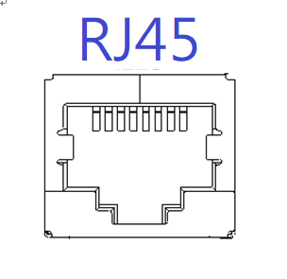

Pin | Pin Name | Pin | Pin Name
1P1 | LAN2_MDI0_P | 2P1 | LAN1_MDI0_P
1P2 | LAN2_MDI0_N | 2P2 | LAN1_MDI0_N
1P3 | LAN2_MDI1_P | 2P3 | LAN1_MDI1_P
1P4 | LAN2_MDI1_N | 2P4 | LAN1_MDI1_N
1P5 | 1CT5 | 2P5 | 2CT5
1P6 | 1CT6 | 2P6 | 2CT6
1P7 | LAN2_MDI2_P | 2P7 | LAN1_MDI2_P
1P8 | LAN2_MDI2_N | 2P8 | LAN1_MDI2_N
1P9 | LAN2_MDI3_P | 2P9 | LAN1_MDI3_P
1P10 | LAN2_MDI3_N | 2P10 | LAN1_MDI3_N

(CN31) Battery CONN
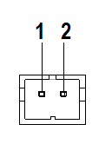

Pin | Pin Name | Signal Type | Signal level
1 | +3.3V | PWR | 3.3V
2 | GND | GND

(CN32) SPI BIOS Debug Port

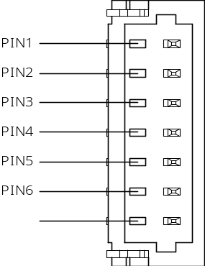

(CN33) M.2 M Key Slot 2280
Pin | Pin Name | Signal Type | Signal level
1 | SPI_MISO | OUT
2 | GND | GND
3 | SPI_CLK | IN
4 | +3.3VSB | PWR | +3.3V
5 | SPI_MOSI | IN
6 | SPI_CS | IN
7 | NC
Standard specification

(CN35) USB Ports 3 and 4

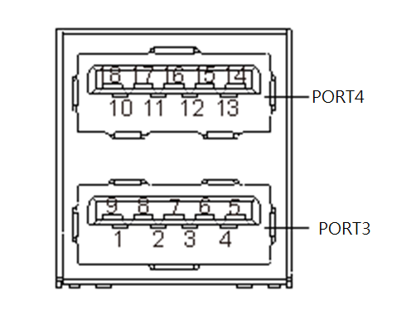

Pin | Pin Name | Signal Type | Signal level
1 | +5VSB | PWR | +5V(0.9A)
2 | USB3_D- | DIFF
3 | USB3_D+ | DIFF
4 | GND | GND
5 | USB3_SSRX− | DIFF
6 | USB3_SSRX+ | DIFF
7 | GND | GND
8 | USB3_SSTX− | DIFF
9 | USB3_SSTX+ | DIFF
10 | +5VSB | PWR | +5V(0.9A)
11 | USB4_D- | DIFF
12 | USB4_D+ | DIFF
13 | GND | GND
14 | USB4_SSRX− | DIFF
15 | USB4_SSRX+ | DIFF
16 | GND | GND
17 | USB4_SSTX− | DIFF
18 | USB4_SSTX+ | DIFF

(CN36)LVDS2 Port

※ LVDS2 LCD_PWR current support => 2A
※ LVDS2 LCD_PWR can be set to +3.3V or +5V by JP8.
 | LVDS
Pin | Pin Name | Signal Type | Signal level
1 | BKL_ENABLE | OUT
2 | BKL_CONTROL | OUT
3 | LCD_PWR | PWR | +3.3V/+5V
4 | GND | GND
5 | LVDS_A_CLK- | DIFF
6 | LVDS_A_CLK+ | DIFF
7 | LCD_PWR | PWR | +3.3V/+5V
8 | GND | GND
9 | LVDS_DA0- | DIFF
10 | LVDS_DA0+ | DIFF
11 | LVDS_DA1- | DIFF
12 | LVDS_DA1+ | DIFF
13 | LVDS_DA2- | DIFF
14 | LVDS_DA2+ | DIFF
15 | LVDS_DA3- | DIFF
16 | LVDS_DA3+ | DIFF
17 | DDC_DATA | I/O | +3.3V
18 | DDC_CLK | I/O | +3.3V
19 | LVDS_DB0- | DIFF
20 | LVDS_DB0+ | DIFF
21 | LVDS_DB1- | DIFF
22 | LVDS_DB1+ | DIFF
23 | LVDS_DB2- | DIFF
24 | LVDS_DB2+ | DIFF
25 | LVDS_DB3- | DIFF
26 | LVDS_DB3+ | DIFF
27 | LCD_PWR | PWR | +3.3V/+5V
28 | GND | GND
29 | LVDS_B_CLK- | DIFF
30 | LVDS_B_CLK+ | DIFF

(CN37)LAN2

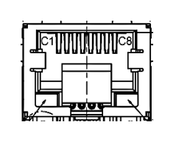

Pin | Pin Name | Signal Type | Signal level
P1 | LAN2_MDI0_P | DIFF
P2 | LAN2_MDI0_N | DIFF
P3 | LAN2_MDI1_P | DIFF
P4 | LAN2_MDI1_N | DIFF
P7 | LAN2_MDI2_P | DIFF
P8 | LAN2_MDI2_N | DIFF
P9 | LAN2_MDI3_P | DIFF
P10 | LAN2_MDI3_N | DIFF

(CN39) USB 2.0 Port 5

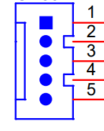
Pin | Pin Name | Signal Type | Signal level
1 | +5VSB | PWR | +5V(0.5A)
3 | USB5_D- | DIFF
5 | USB5_D+ | DIFF
7 | GND | GND
9 | GND | GND

(CN40) USB 2.0 Port 6

Pin | Pin Name | Signal Type | Signal level
1 | +5VSB | PWR | +5V(0.5A)
2 | USB5_D- | DIFF
3 | USB5_D+ | DIFF
4 | GND | GND
5 | GND | GND
(CN41) GPIO Sensor CONN1

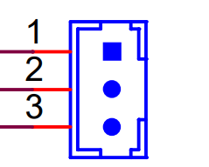

Pin | Pin Name | Signal Type | Signal level
1 | +V5S | PWR | +5V
2 | GPIO3 | I/O
3 | GND | GND

(CN42) GPIO Sensor CONN2

Pin | Pin Name | Signal Type | Signal level
1 | +V5S | PWR | +5V
2 | GPIO4 | I/O
3 | GND | GND

(CN43) Speaker Leftt CONN
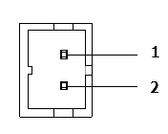

Pin | Pin Name | Signal Type | Signal level
1 | AMP_OUT_L+ | IO
2 | AMP_OUT_L- | IO

(CN44) Speaker Right CONN

Pin | Pin Name | Signal Type | Signal level
1 | AMP_OUT_R+ | IO
2 | AMP_OUT_R- | IO

(CN45) LVDS2 Port Inverter / Backlight Connector

Pin | Pin Name | Signal Type | Signal level
1 | BKL_PWR | PWR | +5V / +12V
2 | BKL_CONTROL | OUT | +3.3V
3 | GND | GND
4 | GND | GND
5 | BKL_ENABLE | OUT | +3.3V

※ LVDS2 BKL_PWR can be set to +5V or +12V by JP8.
※ LVDS2 BKL_PWR current support => 2A
※ LVDS2 BKL_CONTROL can be set by JP9.

(CN46)LAN1

Pin | Pin Name | Signal Type | Signal level
P1 | LAN1_MDI0_P | DIFF
P2 | LAN1_MDI0_N | DIFF
P3 | LAN1_MDI1_P | DIFF
P4 | LAN1_MDI1_N | DIFF
P7 | LAN1_MDI2_P | DIFF
P8 | LAN1_MDI2_N | DIFF
P9 | LAN1_MDI3_P | DIFF
P10 | LAN1_MDI3_N | DIFF

Mating connectors & CABLE List
Connector | Function | Mating Connector |  | Available Cable | Cable P/N
Label | Function | Vendor | Model no | Available Cable | Cable P/N
CN3 | Vin Connector | N/A | N/A | Power Cable | TBD
CN5 | Audio Connector | ACES | 50247-012H0H0-001 | Audio Cable | 170X000156
CN13/CN14 | COM port CONN | Molex | 51021-0900 | UART Wafer cable | 1701090150
CN16 | I2C/SMBUS/  Debug Connector | JST | SHR-12V-S-B | I2C/SM BUS Cable | 1703120130
CN17 | Digital I/O Connector | Neltron | 2026B-10 | N/A | N/A
CN18/CN36 | LVDS Connector | HIROSE | DF13-30DS-1.25C | N/A | N/A
CN20 | eDP Connector |  |  | N/A | N/A
CN22/CN45 | LVDS Inverter Connector | JST | PHR-5 | N/A | N/A
CN23 | CPU Fan Connector | Molex | 22-01-2035 | N/A | N/A
CN31 | External RTC Connector | Molex | 51021-0200 | Battery Cable | 175011901C
CN39/CN40 | USB 2.0 Connector | Molex | 51021-0500 | USB Wafer Cable | 1700050207
CN41/CN42 | GPIO Connector
JP1 | Front Panel Connector |  |  | Power BTN cable

